THE MISUNDERSTANDING OF POSTERIOR TONGUE TIE ANATOMY AND RELEASE TECHNIQUE
by Bobby Ghaheri

When medical providers and parents hear the phrase “tongue tie”, they most commonly picture a tight anterior tongue tie, where the tip of the tongue is tacked down to the floor of the mouth. I have previously described the difference between anterior and posterior tongue tie (PTT) but the concept still eludes many people. One of the most common statements I hear from medical professionals is that “posterior tongue tie doesn’t exist”. The most basic reason why people claim to not “believe” in PTT (as if it were a spiritual issue rather than an anatomical one) is that they know very little about breastfeeding and the relationship with tongue tie. Some of this sentiment comes from a blatant misunderstanding of the anatomy (they think the tie is in the posterior oral cavity near the tonsils). Others don’t understand the concept because they don’t know what normal infant tongues do during breastfeeding (as shown in ultrasound studies). Finally, most medical providers don’t understand proper examination technique, which prevents them from correlating the symptoms with abnormal anatomy.
There are some published data on the presence of PTT. Cliff O’Callahan and colleagues, in a 2013 paper, treated 299 babies with tongue tie. 84% of those babies had PTT; this number includes babies who previously had an anterior tie that was snipped by a different medical provider. Nevertheless, the majority of babies that presented to his office did not have an anterior tie. Dr. O’Callahan demonstrated clinically significant improvements in breastfeeding quality with a frenotomy. To those who don’t believe that PTT exists, I use this study to demonstrate that release of a tongue tie with no anterior frenulum results in clear clinical improvement. A more recent study from 2015 by Pransky and colleagues retrospectively evaluated 618 babies presenting with breastfeeding symptoms. In this study, almost 20% had PTT alone and a further 5% had both PTT and a lip tie. As is the case with the O’Callahan study, the vast majority of babies in this study showed improvement in breastfeeding quality following frenotomy.
A posterior tongue tie is the presence of abnormal collagen fibers in a submucosal location surrounded by abnormally tight mucous membranes under the front of the tongue. As I wrote in a previous post, a classic anterior tongue tie always has a posterior component behind it. Therefore, any tongue tie causing breastfeeding problems is truly a posterior tongue tie; a percentage of those ties also have an anterior component. Failure to release all of the abnormal collagen fibers results in persistent tongue restriction. When providers claim to release 80-90% of the restriction, the dyad can often see 0% improvement. The other major misconception that people have about PTT anatomy is the idea that the tie is somehow “deep” and that it intertwines with the muscles of the tongue. This is not the case. As seen in the diagrams below, the abnormal collagen fibers of the PTT are intertwined within the mucous membrane covering the tongue muscles. The muscle of the tongue beneath this mucous membrane (the genioglossus muscle) is in a completely different tissue layer and is therefore not involved in tongue tie anatomy nor does it need to be involved in the release procedure.
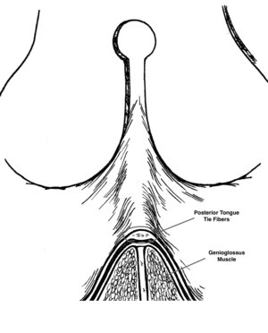
PTT fibers are centrally located in a layer above the genioglossus muscle
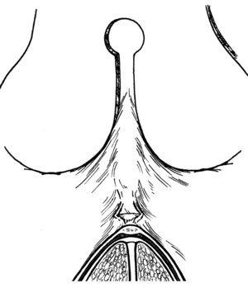
A small window is made through the PTT fibers to begin the release
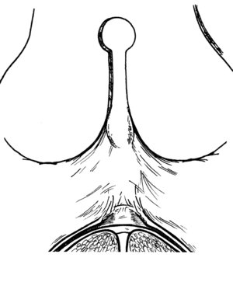

Release of the mucous membrane on either side of the central window
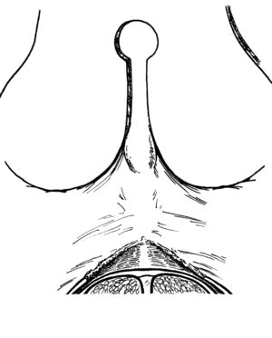
Final diamond-shaped wound is achieved (top half of wound seen here)
Incomplete release of a tongue tie prevents the tongue from achieving its normal movements during breastfeeding. A common fallacy is that a tongue cannot be tied if it can extend out of the mouth beyond the gumline or lips. This is completely untrue. First, the tongue is capable of numerous different movements, and normal mobility in one direction does not guarantee normal mobility in all directions. Furthermore, the motion of the tongue during breastfeeding is very specific - the primary movement that is important is up, not out. I wrote about breastfeeding mechanics, where we have objective evidence from Donna Geddes’ paper in 2008 (and later corroborated by David Elad’s paper in 2014) demonstrating the importance of the upward motion of the tongue. The lack of strong upward movement, inhibited by a tongue tie’s abnormal collagen fibers restricting the tongue to the floor of mouth or mandible, is shown in common symptoms: poor suction/seal on the breast, frequent breaking of the seal with resultant clicking, air intake (aerophagia), slipping off the breast and having to bite down to hold on to the nipple and so forth. These symptoms can occur with bottle feeding as well.
With an understanding of the normal movement of the tongue during breastfeeding, the medical provider and lactation consultant MUST change how they examine the baby. Without challenging the upward movement of the tongue, they will never understand if a visible and palpable restriction exists. I have previously written about proper examination technique to try and standardize our approach to infant oral examinations.
Along with the misconceptions about PTT anatomy come misconceptions about PTT release. Many able and skilled providers combine a poor examination technique with apprehension about PTT release. Why is there apprehension about the procedure? The most common reason is the misunderstanding of how deep one must travel to fully release the tethered fibers. As I stated above, the PTT fibers intertwine with the mucous membrane and do not involve the muscle. Proper release technique involves a central release of the fibrous band and then a release of the mucous membrane on either side of the central band. One must release the mucous membrane lateral to the band (resulting in a diamond-shaped wound) because the mucous membrane around the tie has shrink wrapped around the muscle to only allow the movements that were present prior to the tie release. Once the central band is released, you must also release the mucous membrane to allow the tongue to actually move up. The actual depth of the initial incision is surprisingly shallow (approximately 1mm). Neither the central release nor the lateral mucosal releases involve the muscle, so bleeding is kept to a minimum. Also contrary to popular belief, a PTT can be released with laser is far superior as there is much more control,
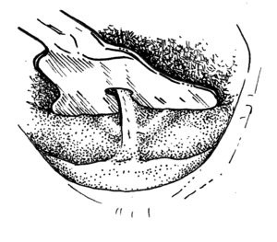
Looking from the top down, the grooved director lifts the tongue out of the way, isolating the posterior tongue tie
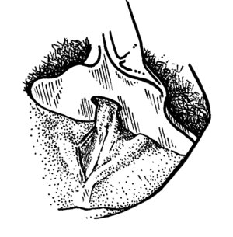
After central release is made, the mucous membrane release on one side is started
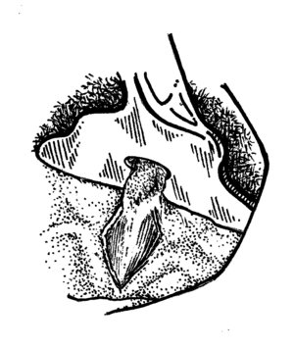
Release is carried to other side
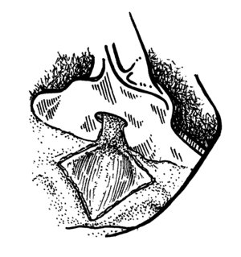
Final diamond-shaped wound is achieved with higher lift with the grooved director
I sincerely hope this post helps to clarify PTT anatomy and to demystify the procedure needed to release tongue ties properly. If you are a clinician reading this and would like additional pictures, videos, or descriptions of the procedure, please email me using the link at the top of my page. For parents, using this post may help your doctors understand PTT anatomy and that a tie can occur without an obvious visible frenulum. For clinicians looking to improve their clinical skills, I highly recommend shadowing a provider who performs this procedure frequently (and for those inclined, you may shadow me by contacting me). This improved understanding of PTT will decrease the number of inadequately released frenula and improve long term breastfeeding success.

